**12 ATAR Physics**

**Hubble's Law (Part 2) 2019**

**Name: Mark: $\frac{}{\text{27}}$**

**The Big Bang Theory & Hubble’s Law**

1. Using the data points collected previously in part 1, plot a correctly-labelled graph to determine an accurate value of Hubble’s constant. [4 marks]

|  |
| --- |
|  |

2. Use the graph to calculate a value for Hubble’s constant, including the correct units. [4 marks]

3. Determine the age of the universe (in billions of years) according to the data you have graphed.

[4 marks]

4 A line in the spectrum of ionised potassium has a wavelength of 422.3 nm when measured in the laboratory. When similar light from the galaxy NGC 5170 is measured, its wavelength is 424.4 nm.

(a) Calculate the red-shift of this galaxy. [3 marks]

(b) Calculate the recessional speed of this galaxy in kms-1. [3 marks]

(c) For the recessional speed previously calculated, use your graph to determine the distance to this galaxy in Mpc. [1 mark]

(d) Determine how many years it takes for light from galaxy NGC 5170 to reach Earth. [2 marks]

5. (a) What is meant by the term "red-shift"? Use the following diagram to assist your explanation. [2 marks]

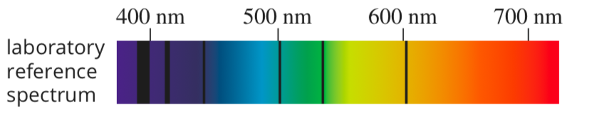

(b) What did Hubble find when he observed the light from distant galaxies, as compared to light from closer galaxies? [2 marks]

(c) How do Hubble's observations support the concept of an expanding universe?

[2 marks]